**Introduction:**

The “Bus Ticket Reservation System” has been developed to override the problems which exist in the practical manual system. In our daily life we have to book tickets for various purposes. Doing this manually can become tough. So, we are developing this system to manage booking of ticket automatically. In this project we develop the system that can help the user to book their ticket online. It is a Web based desktop application.

This reservation system has three modules. First module helps the user to select the pick-up point and destination with corresponding date and time. Using second module he can reserve a ticket and also choose the number of tickets. The third module helps the user to choose the payment option.

**User Category:**

There are two types of Users here. They are:

* Admin
* User (Customer)

**Feature List:**

In this project the “Admin” has the following features:

* Admin can maintain all Customer’s information.
* Admin can maintain the Bus information.
* Admin can maintain the Ticket information.

In this project the “Customer” has the following features:

* Any visitor can visit our system.
* Customer can register their information in the system.
* Customer can check the pick-up point, destination, date and time to book a ticket.
* Customer can select his/her desired seat (they can also select multiple seats).
* Customer can pay through some mobile banking systems.

**GUI Description:**

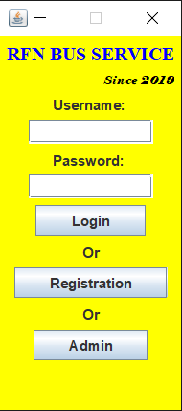

The first GUI viewed by the user is the LoginGUI which contains two text field (username and password) and three buttons (Login, Registration and Admin).

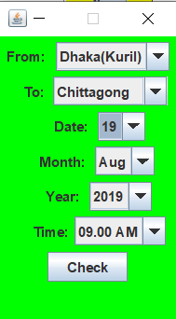

Upon clicking the Login button input from the user and logging in, the user can now view the BusScheduleGUI and select accordingly.

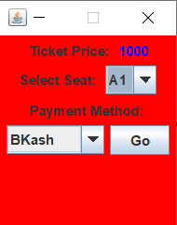

Finally after checking the time and place user will be able to select his/her desired seat and payment method in the TicketPriceGUI.

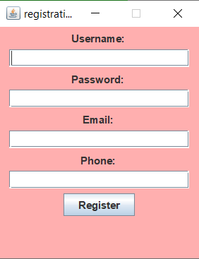

The RegistrationGUI helps the user to provide his/her information. Upon successful registration a message will appear.

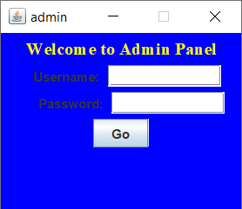

Upon clicking the Admin button the AdminGUI will show up. Admin has to login with his username & password.

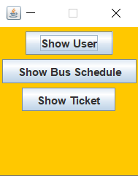

Here admin can see all the information of Users, BusSchedule & TicketPrice in the AdminInfoGUI upon clicking three buttons given in the GUI.

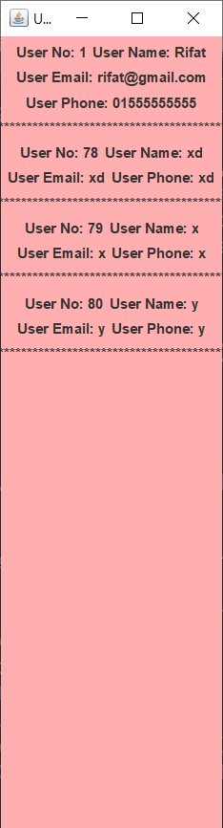

It’s the ShowUserInfoGUI.

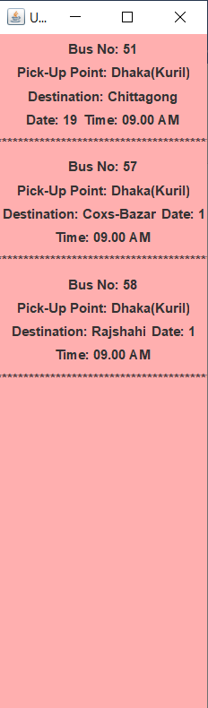

It’s the ShowBusInfoGUI.

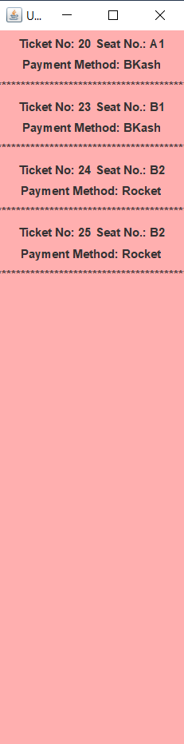

It’s the ShowTicketInfoGUI.

**Database Table Description:**

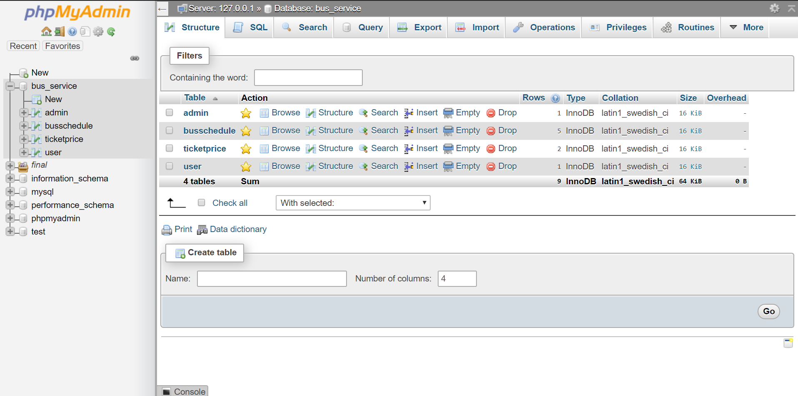

**Class Diagram:**

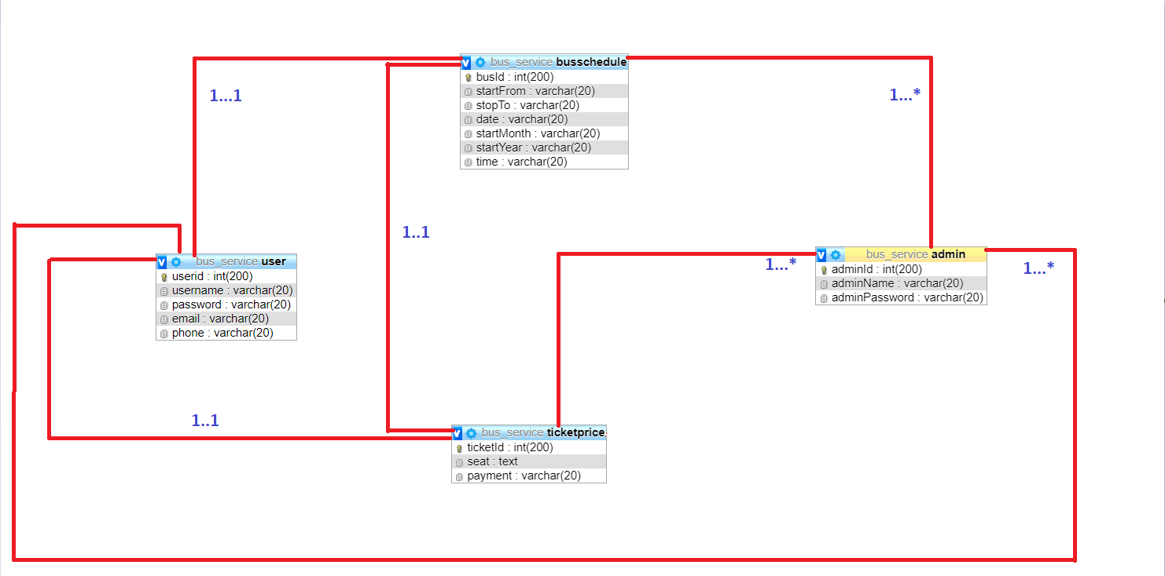

**Tools Used:**

To develop this project we have used the following:

* Sublime-Text 3.0

**OOP and Java Concepts Used:**

* **Inheritance:** **Inheritance** is a mechanism in which one object acquires all the properties and behaviors of a parent object. It is an important part of OOPs (Object Oriented programming system). Inheritance represents the **IS-A relationship** which is also known as a parent-child relationship.
* **Polymorphism:** **Polymorphism** is a concept by which we can perform a single action in different ways. Polymorphism is derived from 2 Greek words: poly and morphs. The word "poly" means many and "morphs" means forms. So polymorphism means many forms.
* **Encapsulation:** Encapsulation is a mechanism of wrapping the data (variables) and code acting on the data (methods) together as a single unit. In encapsulation, the variables of a class will be hidden from other classes, and can be accessed only through the methods of their current class. Therefore, it is also known as data hiding.
* **Abstraction:** **Abstraction** is a process of hiding the implementation details and showing only functionality to the user. It helps to reduce programming complexity and effort.
* **Exception Handling:** The Exception Handling in Java is one of the powerful mechanism to handle the runtime errors so that normal flow of the application can be maintained. In Java, an exception is an event that disrupts the normal flow of the program. It is an object which is thrown at runtime.

**Impact of this Project:**

It is a modern approach to booking tickets which saves time for both users and employees. It remains open 24/7 for reservation. RFN Bus Service will work by providing a secure and customizable platform by which customers can see seat availability, book and pay all on our application. The impact online booking platform can have on a business, boosting sales and greatly simplifying the booking procedure for both customers and staff.

**Limitations and Possible Future Improvements:**

**Limitations:**

**01**. The fare is fixed.

**02**. We have only one bus in our system.

**03.** The bus and ticket availability was not checked.

**04.** Pick-up point & Destination can be same.

**Possible Future Improvements:**

1. The fare will vary from place to place.
2. We will add multiple bus options.
3. The availability of bus & ticket will be checked.
4. Pick-up points & destinations won’t be same.
5. User will be able to cancel the reservation.
6. We’ll add more pickup points & destinations.
7. We’ll add more payment options.